**IN2210 Object Oriented Analysis and Design**

**Assignment 2**

**Sequence Diagram - NFT Marketplace**

**Troyrangers**

**204087F Jayathilake PHP**

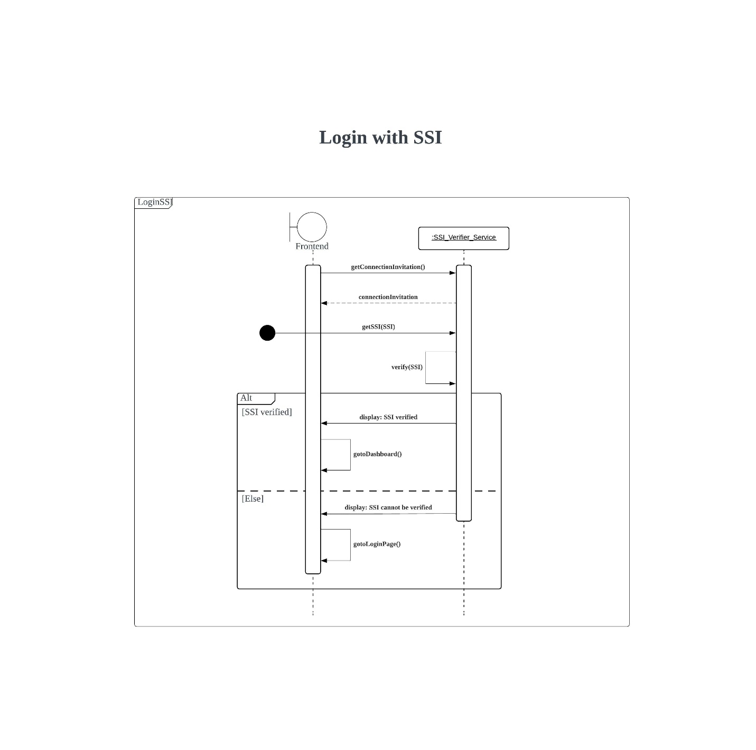In our Blockchain – Based Vehicle Registration and Ownership Management System, we have a platform to sell and buy vehicles. This is an open system for any user. Anyone can access the system through their Self Sovereign Identity (SSI).

